**FUNCTIONAL AND TECHNICAL COMBINED DOCUMENTATION**

**Page (43): Edit Profile (Front End Url:** http://localhost:8100/page43/page43)

**Functional Picture:**

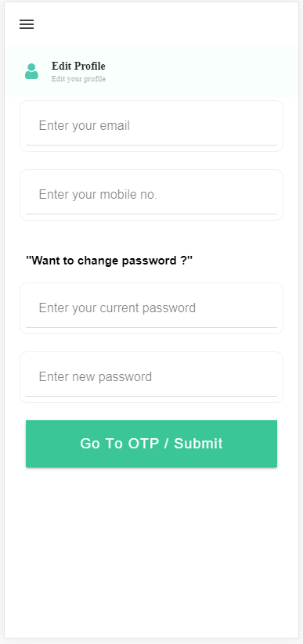

**Technical Explanation (Front End and Back End):**

**In Page43.tsx, we are calling following one API:**

1. EditCredential: see view.py python file from BackEnd

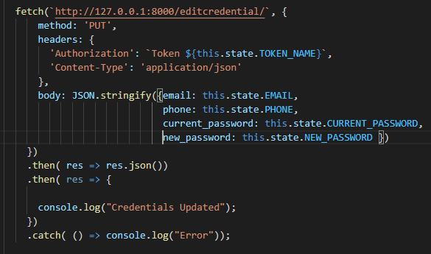

**As you can see above, there is one url:**

* [**http://127.0.0.1:8000/editcredential/**](http://127.0.0.1:8000/editcredential/) **--🡪** EditCredential

**In** EditCredential API, we are doing a “POST” request for email, phone, current password and new password and we are saving phone number in **UserProfile** model. After authenticating the user, we are setting the new password along with the new email.

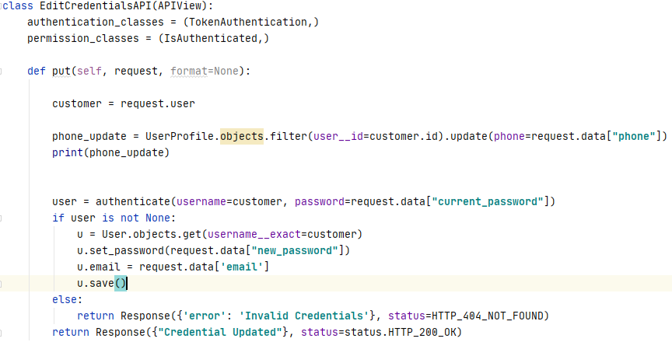

Kindly see this path in the urls.py:



DONE!!!